**Underline** :- **Primary key**

**~~Crossline~~ :- Foreign key**

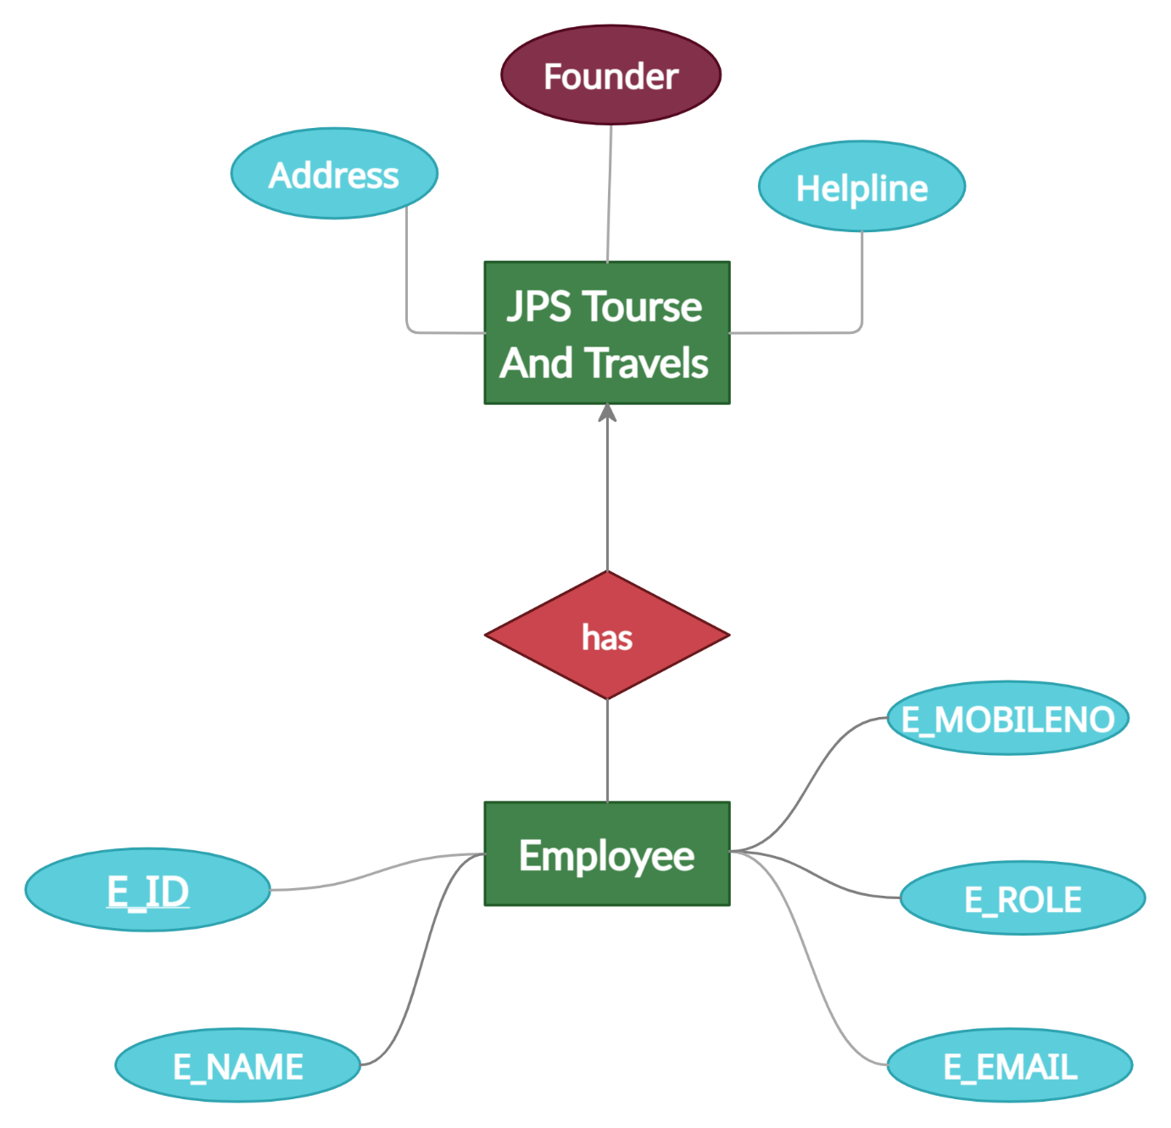

* ***JPS Tours And Travels (Founder,Address,Helpline)***
* As the Entity Jps tours and travels have only relation with Employee which is **one to many** relation so there is no change in its relational attributes
* The has relation is uniquely define by the primary key of the employee as there is no such primary key for entity JPS Tours And Travels

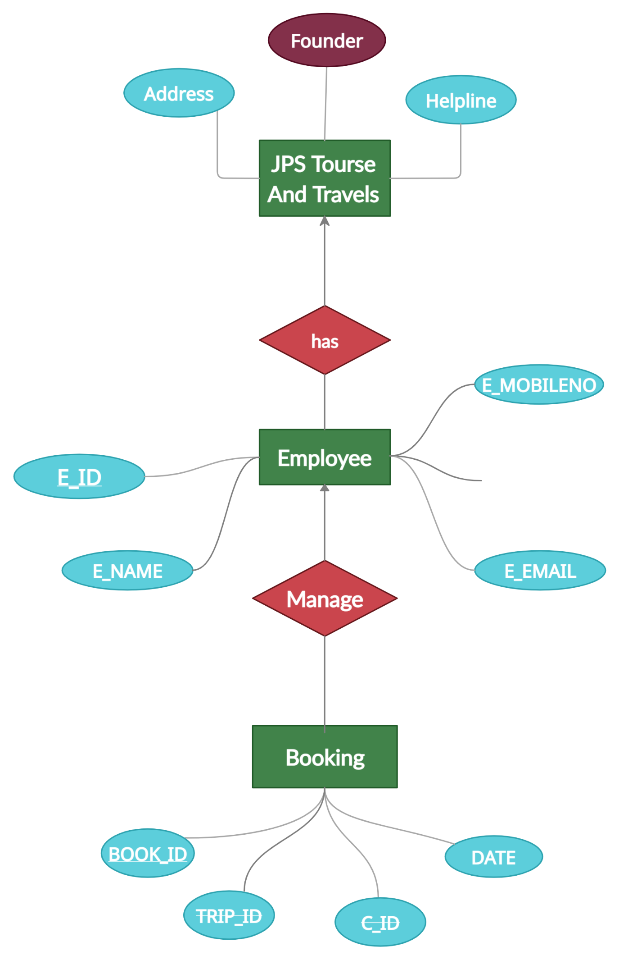

* ***Employee (E_ID,E_NAME,E_MOBILENO,E_ROLE,E_EMAIL)***
* AS the “Employee” has the **many to one** relation with “Jps tours and travels” and **no total participation** so due to it there is no change in relational attributes of “Employee”.
* Also “Employee” has the **one** **to many** relation with “Booking” so due to it there is no change in relational attributes of “Employee”.
* The relation between manages uniquely identify by the Primary key of Both the relation like

**Manages(E_ID,BOOKING_ID)**

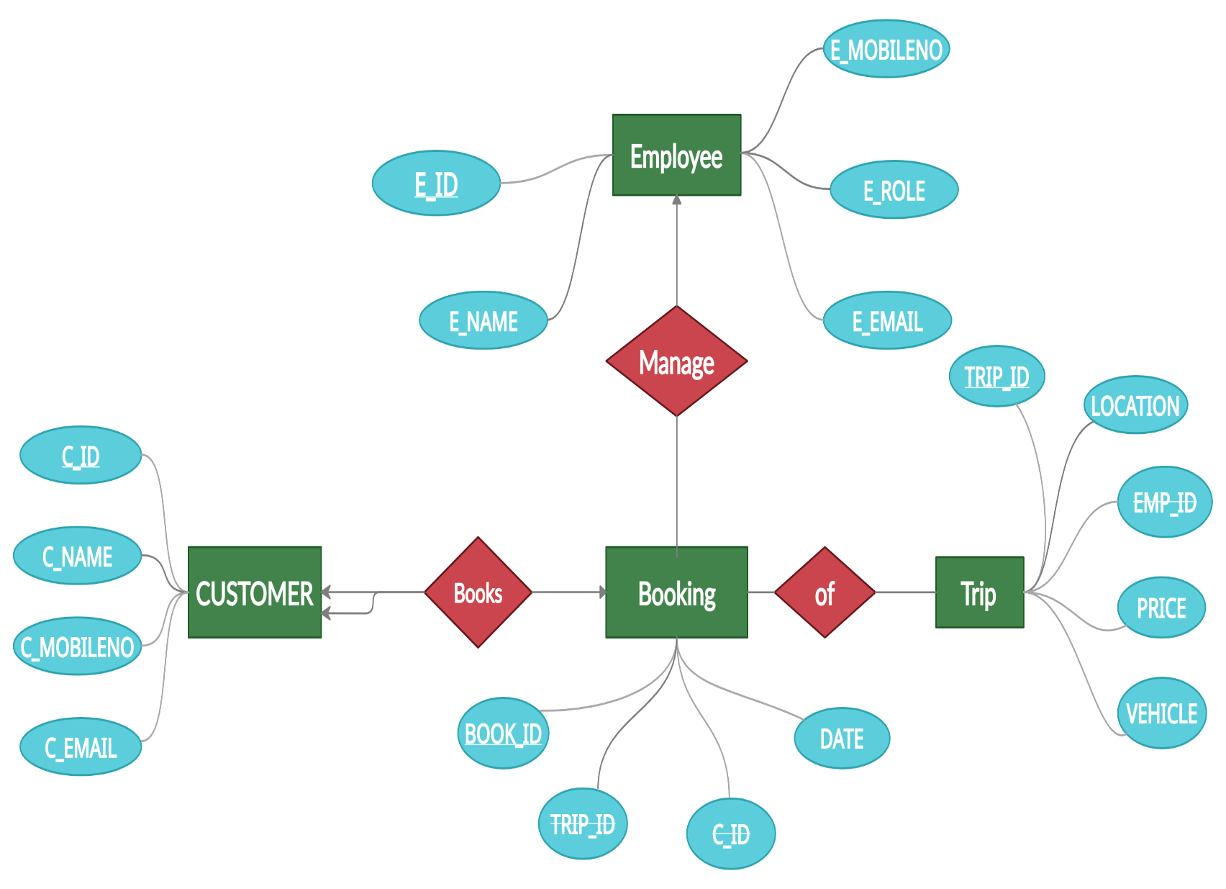

* ***Booking (BOOK_ID,TRIP_ID,~~C_ID~~,DATE)***
* AS the “Booking” has the **many to one** relation with “Employee” and **no total participation** so due to it there is no change in relational attributes of “Booking”.
* AS the “Booking” has the **many to one** relation with “Customer” and **no total participation by Booking** so due to it there is no change in relational attributes of “Booking”.
* AS the “Booking” has the **many to many** relation with “Trip” so due to it there is no change in relational attributes of “Booking”.

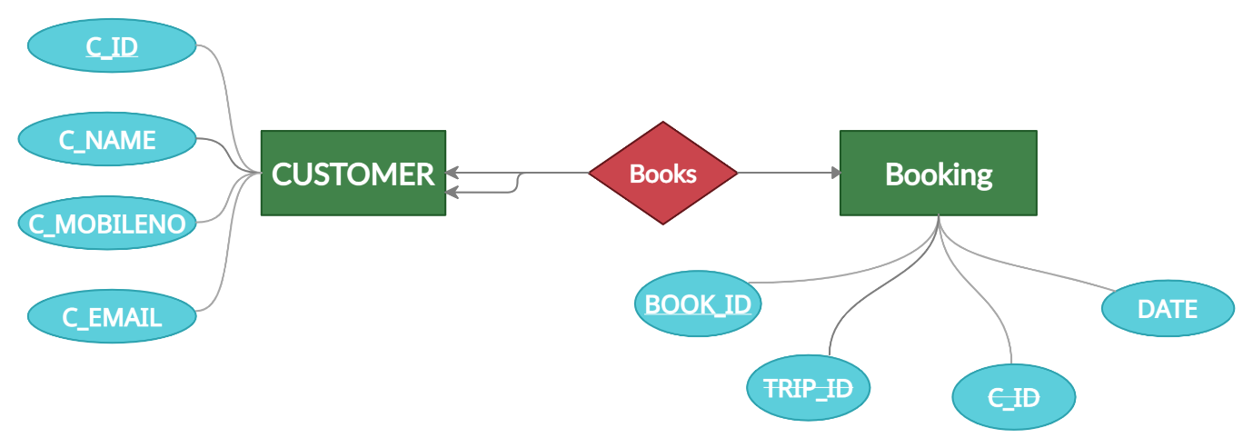

* ***Customer (C_ID,C_NAME,C_MOBILENO,C_EMAIL,~~BOOK_ID~~)***
* As Entity “Customer” have only relation with the “Booking” which is **Many to one** and here **customer have total participation with relation Books** so customer and books will merge so booking primary key will be given as foreign key to the customer

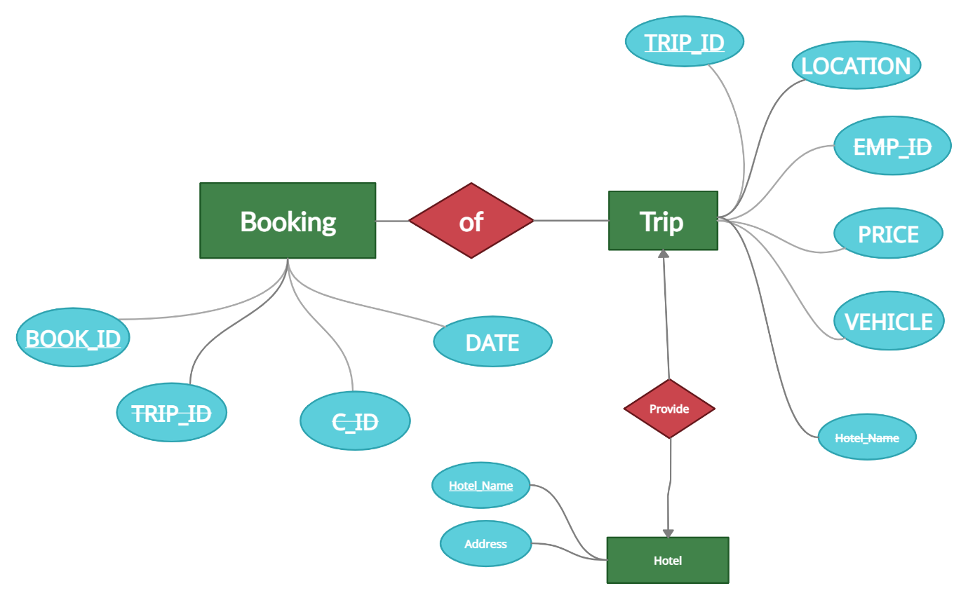

* ***Trip (Trip_Id,Location,~~Emp_id,~~Price,Vehicle~~,Hotel_name~~)***
* AS the “Trip” has the **many to many** relation with “Booking” so due to it there is no change in relational attributes of “Trip”.
* AS the “Trip” has the **one to one** relation with “Hotel” and **no total participation** so due to it there is no change in relational attributes of “Trip”.
* OF relation will uniquely identify by the primary key of Booking and Trip

**OF (BOOK_ID,TRIP_ID)**

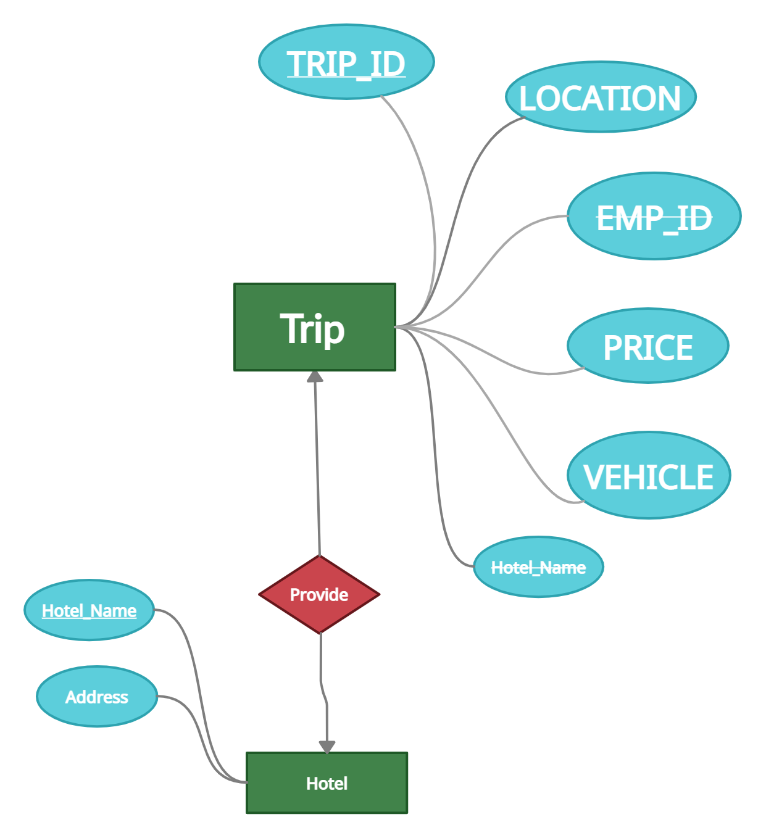

* ***Hotel (Hotel_name,Address)***
* AS the “Hotel” has the **one to one** relation with “Trip” and **no total participation** so due to it there is no change in relational attributes of “Hotel”
* The relation **“Provide”** will uniquely identify by the primary key of Hotel and Trip

***Provide (TRIP_ID,HOTEL_NAME)***

* **Relational entity and attributes**
* ***JPS Tours And Travels (Founder,Address,Helpline)***
* ***Employee (E_ID,E_NAME,E_MOBILENO,E_ROLE,E_EMAIL)***
* ***Booking (BOOK_ID,TRIP_ID,~~C_ID~~,DATE)***
* ***Customer (C_ID,C_NAME,C_MOBILENO,C_EMAIL,~~BOOK_ID~~)***
* ***Trip (Trip_Id,Location,~~Emp_id,~~Price,Vehicle~~,Hotel_name~~)***
* ***Hotel (Hotel_name,Address)***
* **Relation**
* ***Provide (TRIP_ID,HOTEL_NAME)***
* **OF (BOOK_ID,TRIP_ID)**
* **Manages(E_ID,BOOKING_ID)**